Sunday: 10 May: 6th Sunday of Easter

__________________________________________________________________________________________________
Plenary Indulgence during the Year of Consecrated Life!
On the occasion of this special Year, Pope Francis has conceded plenary indulgences, under the customary conditions:
the individual be in the state of grace by the completion of the acts, have complete detachment from sin, and pray for the Pope's intentions. The person must also sacramentally confess their sins and receive Communion, up to about twenty days before or after the indulgenced act.

The period for gaining this indulgence began on the First Sunday of Advent 2014 and will conclude on February 2, 2016, the day of the closure of the Year of Consecrated Life. In the Diocese of Lafayette a plenary indulgence may be obtained during those days devoted to consecrated life and during diocesan celebrations organized for the Year of Consecrated Life (by participating in any Votive Mass for Consecrated or Religious Life, Vocations Awareness, Jubilarian Mass, etc) or by visiting any of the following designated places:

- Cathedral of Saint John the Evangelist, Lafayette
- Immaculate Heart of Mary Church, Lafayette
- Saint Charles Borromeo Church, Grand Coteau
- Saint Martin de Tours, St. Martinville
- Mother of the Redeemer Monastery, * Plaisance
- Carmelite Monastery, * Lafayette
- Mater Dolorosa Chapel, *St. Martinville

In order to obtain the plenary indulgence, one must publicly recite the Liturgy of the Hours (please note places that are marked with an asterisk all have public recitation of the Divine Office; please contact them for times) or devote a suitable period of time for devout reflection, concluding with the Lord’s Prayer, the Creed, and pious invocation of the Virgin Mary.

Prayer for the Year of Consecrated Life
O God, throughout the ages you have called women and men to pursue lives of perfect charity through the evangelical counsels of poverty, chastity, and obedience. During this Year of Consecrated Life, we give you thanks for these courageous witnesses of Faith and models of inspiration. Their pursuit of holy lives teaches us to make a more perfect offering of ourselves to you. Continue to enrich your Church by calling forth sons and daughters who, having found the pearl of great price, treasure the Kingdom of Heaven above all things. Through our Lord Jesus Christ, your Son, who lives and reigns with you in the unity of the Holy Spirit, one God forever and ever. Amen
__________________________________________________________________________________________________

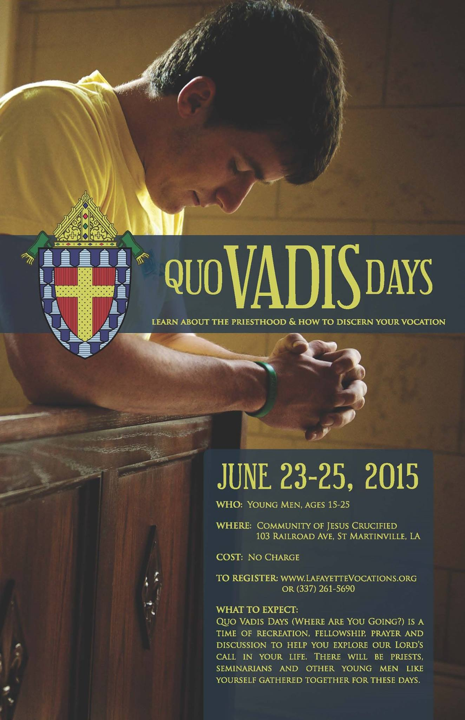
________________________________________________________________________________________________

Please add a Happy Mother’s Day graphic somewhere in the bulletin. Thanks!

__________________________________________________________________________________________________
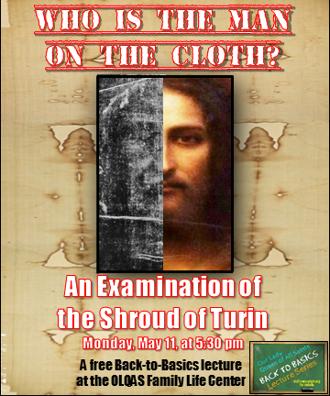________________________________________________________________________________________________

You’re Invited to an Open House
In Observance of the Year of Consecrated Life
Our Lady of Sorrows Retreat Center
103 Railroad Ave., St. Martinville, LA
E I N V I T E D T O WHEREYI
SUNDAYS: April 26, May 24, June 28, July 26, Aug. 30
Sept. 27, Oct. 18, Nov. 22, Dec. 27
Get a close-up view of the Consecrated Life and gain a Plenary Indulgence
Pray Midday Prayer and Evening Prayer with the Community of Jesus Crucified
(Midday Prayer 11:45am • Evening Prayer 6:15pm • Holy Mass 12 noon)
The Gate and Chapel will open from 8:30am till 6:30pm.

For More Information, call Fr. Michael Champagne at
(337) 394-6550
______________________________________________________________________________________________
We will be hosting organist Christopher Lynch as he performs an organ recital on Tuesday, May 19, 2015, at 6:30 p.m. in the church. The recital is open and free to the public. A reception will follow in the parish meeting room. For more information, please contact Mr. Ben L. LeBleu, Director of Sacred Music, at 337-363-2989.
______________________________________________________________________________________________

Parking Lot:
Please leave the traffic cones in the spaces that are placed in the NO PARKING areas. We ask that you DO NOT REMOVE OR RELOCATE THESE CONES.
___________________________________________________________________________________________

Sacred Heart High School Baccalaureate Mass will be Sunday, May 17th at 11:30 a.m.
__________________________________________________________________________________________________
Adoration Chapel
We are blessed, here in Ville Platte, to have Perpetual (twenty-four hour) Adoration of the Blessed Sacrament available to us at the Mercy Regional Hospital Chapel. Parishioners are invited to stop by the chapel and spend some time, as often as they wish, in prayer before Our Lord in the Blessed Sacrament. If you are interested in becoming a regularly scheduled adorer or a substitute adorer, please phone 337-363-4533 for more information. There are currently openings for adorers Sundays at 1 a.m. and 5 a.m. Please phone the number above, if you are interested in taking one of these vacancies.

“Of all devotions, that of adoring Jesus in the Blessed Sacrament is the greatest after the sacraments, the one dearest to God and the one most helpful to us. – St. Alphonsus of Liguori

____________________________________________________________________________________________

Prayers for our Diocesan Priests:
Each day, please remember the following Priests in prayer:
Sunday, May 10: Rev. Glenn Meaux, Monday, May 11: Rev. Aaron Melancon, Tuesday, May 12: Rev. Bill Melancon, Wednesday, May 13: Msgr. Louis Melancon, Thursday, May 14: Rev. Mark Melancon, Friday, May 15: Rev. Jerry Mesley, Saturday, May 16: Rev. Andre Metrejean, Sunday, May 17: Msgr. Paul Metrejean
Eternal Father, we lift up to You these and all the priests of the world. Sanctify them. Heal and guide them. Mold them into the likeness of Your Son, Jesus, the Eternal High Priest. May their lives be pleasing to You. In Jesus’ name we pray. Amen.
___________________________________________________________________________________________
Necrology:
Please remember the souls of these departed Priests, Deacons, Bishops, and other religious who have served our Diocese: Friday, May 15: Rev. Francis I. Bishof (+1961), Rev. Marcel Gaudet (+1976)
Requiem aeternam dona eis, Domine et lux perpetua luceat eis.
__________________________________________________________________________________________________

Readings for the week: Monday, May 11: Acts 16:11-15, Jn 15:26 – 16:4a; Tuesday, May 12: Acts 16:22-34, Jn 16:5-11; Wednesday, May 13: Acts 17:15, 22-18:1, Jn 16:12-15; Thursday, May 14: Acts 1:15-17, 20-26, Jn 15:9-17; Friday, May 15: Acts 18:9-18, Jn 16:20-23; Saturday, May 16: Acts 18:23-28, 30-31, Jn 16:23b-28
Sunday, May 17, readings for Holy Mass: Worship hymnal page 1094
__________________________________________________________________________________________________

Intentions of Pope Francis for the Month of May:
Universal: That, rejecting the culture of indifference, we may care for our neighbors who suffer, especially the sick and the poor.
Evangelization: That Mary’s intercession may help Christians in secularized cultures be ready to proclaim Jesus.
________________________________________________________________________________________________

∼ From the Pastor ∼

“My heart's desire and prayer to God for them is that they may be saved.” Romans 10:1

______________________________________

Mes chers amis,

Today, our nation pauses to remember our Mothers with honor and gratitude. What a precious gift He has given to the world and to us personally in our Mothers. Below I offer you the words of St. John Paul II about the gift and mystery of Mary’s motherhood for all Mothers today.

Mary’s ‘hidden life’ is an example to Mothers

“The Gospels offer very sparse information about the years the Holy Family spent in Nazareth. St Matthew tells of the decision taken by Joseph, after the return from Egypt, to make Nazareth the Holy Family’s permanent home (cf. Mt 2:22-23), but then gives no further information except that Joseph was a carpenter (Mt 13:55). For his part, St Luke twice mentions the Holy Family’s return to Nazareth (cf. Lk 2:39, 51) and gives two brief references to the years of Jesus’ childhood, before and after the episode of the pilgrimage to Jerusalem: “The child grew and became strong, filled with wisdom; and the favor of God was upon him” (Lk 2:40), and “Jesus increased in wisdom, age and grace before God and men” (Lk 2:52).

In relating these brief remarks about Jesus’ life, Luke is probably referring to Mary’s memories of a period of profound intimacy with her Son. The union between Jesus and the one who was “full of grace” goes far beyond what normally exists between mother and child, because it is rooted in a particular supernatural condition and reinforced by the special conformity of both to the divine will. Thus we can conclude that the atmosphere of tranquility and peace in the house of Nazareth and their constant seeking to fulfill God’s plan gave an extraordinary and unique depth to the union of mother and son.

Mary’s awareness that she was carrying out a task entrusted to her by God gave a higher meaning to her daily life. The simple, humble chores of everyday life took on special value in her eyes, since she performed them as a service to Christ’s mission.

Mary’s example enlightens and encourages the experience of so many women who carry out their daily tasks exclusively in the home. It is a question of a humble, hidden, repetitive effort, and is often not sufficiently appreciated. Nonetheless, the long years Mary spent in the house of Nazareth reveal the enormous potential of genuine love and thus of salvation. In fact, the simplicity of the lives of so many housewives, seen as a mission of service and love, is of extraordinary value in the Lord’s eyes. “
(St. John Paul II - General Audience, January 29, 1997)
Dans le Sacré Cœur du Christ,
Fr. Vidrine

_________________________________________________________________________________________________
Please remember the sick in your prayers: Huey Daire, Barbara Delafosse, Stephen Denney, Raymond Dupre, Scott Dupre, Ambros Fontenot, Carenia Ardoin Fontenot, Clyde Fontenot, Kristen Smith Fontenot, Danny Manuel, and Sybil Vidrine.
_________________________________________________________________________________________________

Altar Servers for the Weekend of 16 May – 17 May
Sat., 4 p.m. (BC) Evan Miller
Sat., 4 p.m. Rivers Lanclos
Sun., 7 a.m. Laura Manuel
Sun., 10 a.m. Tre & Dreu Fontenot, Seth Menard
Sun., 5 p.m. Nick Bellow

Readers for the Weekend of 16 May – 17 May
Sat., 4 p.m. (BC) Paul Roy Fontenot
Sat., 4 p.m. Jim Soileau
Sun., 7 a.m. Harold Stromer
Sun., 10 a.m. Annette Fontenot
Sun., 5 p.m. Dennis Fontenot

Extraordinary Ministers of Holy Communion for the Weekend of 16 May – 17 May
Sat., 4 p.m. (BC) Margaret Fontenot
Sat., 4 p.m. Verna Guillory, Elaine Sonnier
Sun., 7 a.m. Perry & Bonny Meche
Sun., 10 a.m. Elena DeRouen, June Hamlin
Sun., 5 p.m. Ruth Fontenot, Sybil Vidrine

Altar Servers for the week of 11 May – 15 May
Mon. May 11, 6:30 a.m. Tre & Dreu Fontenot
Tues. May 12, 6:30 a.m. Chase Bordelon
Wed. May 13, 6:30 a.m.
Thur. May 14, 6:30 a.m. Megan Donovan
Fri. May 15, 6:30 a.m. Rivers Lanclos
____________________________________________________________________________________________

Sacred Heart Sanctuary Light is in memory of: Ruth Ardoin and Mary Ann Lane Ardoin

_____________________________________________________________________________________________

Advertiser of the Week:

John L. Soileau, Inc. Off Shore Catering

May we suggest that you regularly flip over the back page of our bulletin and check our sponsors and advertisers. Through their generosity, our bulletin is made possible. We would like to express our thanks to them for their ongoing support.
__________________________________________________________________________________________________

Intentions for Holy Mass

Saturday, 9 May 2015
4 p.m. BC: For Parishioners
Also remembered in prayer: Janet DeVille & Family, Mr. & Mrs. David Fontenot & Family, Lelia Fontenot, Lorise Fontenot, Laberta Lafleur, Rose Thompson, Estelle Fontenot, Peggy & Brady Hudspeth, Dale Sittig, Lena Williams, Loyce Dupre, Harrise Joubert, Eve Fontenot, Ruth Crosby, Eloise Fontenot, Elizabeth Marie Fontenot

4 p.m.: Lionel LaHaye, Mr. & Mrs. Martin LaHaye, Nellie & Delta Doucet
Also remembered in prayer: Anna Deshotels, Orise & Ruby Fontenot, Burnel Fuselier, Howard & Judy Deshotel, Lionel & Ollie Ardoin, Mr. & Mrs. Willie Ardoin, Mr. & Mrs. Lawrence Sylvester, Irving & Bonnie Manuel, Doris & Rose Dupre, Deceased family of Lake Lafleur, Lee Ray Guillory, Russell Hull, Percy & Hazel Sylvester, Henry & Louisa Fontenot, Euwell & Bernice Fontenot, Rose Belle & J.D. Guillory & Family, Amy (Birthday) & Vincent Phillips & Family, Bruce & Geraldine Soileau, Hilda Lafleur, Rose Emily Soileau, Rose Coreil, Yvonne Prudhomme, Brenda Aswell Fontenot, Debbie Wiggins Curole, Elva Tate, Peggy S. Fontenot, Yvette Soileau, Betty Ann Guillory, Joseph Calvin Soileau, Annie Vidrine, Mary Ella Ardoin Soileau

Sunday, 10 May 2015
7 a.m.: Dean Soileau & Family, Mr. & Mrs. Claude Fontenot & Family, Vivian Soileau, Jessie Soileau
Also remembered in prayer: Audrey Guillory, Essie & Calvin Fontenot, Richard Fontenot, Eza DeVille, Loude Lafleur, Ernestine DeVille, Una R. Fontenot, Eva S. & Ray J. Lafleur, Eunice, Vernon & Marla Prudhomme, Mr. & Mrs. Steve Castille, Mr. & Mrs. Allen Buller, Joe & Marjorie Ardoin, Mr. & Mrs. Elzia Thibodeaux, Etta T. Fontenot, Elvy Thibodeaux, Mr. & Mrs. Vincent Fontenot, Sr. & Jr., Mr. & Mrs. Auther B. Fontenot, Bernita F. Soileau & Family, Jessie Brown, Rogers Brown, Adam Corona, David Sebastien, Emily & George Catoire, Janet Ardoin, Onezia, Vicki & Louis Vidrine, Zetta & LouElla Bordelon

10 a.m.: Neva W. Manuel, Paul Manuel
Also remembered in prayer: Eura Soileau & Family, Inez & Ursula Attaway, Mary Reed, Rose Demoruelle, Harvey LeBas Family, Mrs. Kathleen S. Soileau, Sally Duplechin, Mary Arden Duplechin, Harry & Leavanna Vidrine, Brett Fontenot, Cristina G. Morales, Gloria F. Grim, Laperle G. Fontenot, Marie Soileau, Anna Sebastien, Zack Guillory, Cloynise Lachney, Pearl McDaniel Foret, Gloria Ardoin, Nazel Vidrine, Pearl Attales, Yvette Soileau, Betty Ann Guillory, Joseph Calvin Soileau, Melba R. Deshotel, Albert Deshotel, Lessie Deshotel, Emily Deshotel, Eldridge Deshotel, Peggy & Brady Hudspeth, Dale Sittig, Lena Williams, Rynell Fontenot, Anna Belle Sebastien, Bernice Soileau, Melicia Sonnier, Evangeline LeBleu, Roderick Demoruelle, Grace Fontenot, Juanita Wilks, Mr. & Mrs. Elton McCauley, Kernie , Rayburn & Ermon McCauley, Mr. & Mrs. Avy L. Granger, Mary Ann Lane Ardoin, Ruth Ardoin, Armide Ardoin

5 p.m.: Don & Lena Franks, Eldridge & Christine Landreneau, Luis Cantu
Also remembered in prayer: Theresa Reed

Monday, 11 May 2015
6:30 a.m.: Peggy & Brady Hudspeth, Dale Sittig, Lena Williams

Tuesday, 12 May 2015
6:30 a.m.: Peggy & Brady Hudspeth, Dale Sittig, Lena Williams
Also remembered in prayer: Craig M. Fontenot, Douglas & Irene Fontenot, Mr. & Mrs. Maurice Trahan, Martha & James McDonald, Cavolyn Tate

Wednesday, 13 May 2015
6:30 a.m.: Priests, Seminarians, & Religious
Also remembered in prayer: Peggy & Brady Hudspeth, Dale Sittig, Lena Williams, Percy David

8:10 a.m.

Thursday, 14 May 2015
6:30 a.m.: Rudy Guillory, Therman James, Deceased members of the Firmin Family
Also Remembered in prayer: Anthony Reed, Judge Burton Foret, Peggy & Brady Hudspeth, Dale Sittig, Lena Williams

Friday, 15 May 2015
6:30 a.m.: Peggy & Brady Hudspeth, Dale Sittig, Lena Williams

8:10 a.m.:

Saturday, 16 May 2015
8 a.m.: John Trahan (Birthday)

